6A^{th} Grade: Unit 1, Lesson 7

- Write a division equation that could be represented by the tape diagram.
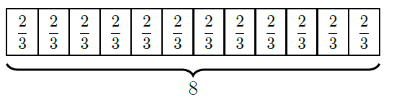

$$8÷\frac{2}{3}=12$$

- What is value of the expression $\left(\frac{8}{9}\right)\left(\frac{2}{3}\right)$?

$$\frac{16}{27}$$

- Rewrite the expression $\frac{7}{9}÷\frac{1}{3}$ as a multiplication expression.

$$\frac{9}{7}×3$$

